AIRPORT TRANSPORTATION
Please carry a copy of the electronic airline ticket while you travel. It helps to have a paper copy of the electronic ticket in case a flight is cancelled and you must reschedule mid-trip. If you will check luggage through the airline, confirm it is tagged to your destination airport. The luggage tag code for the Indianapolis, Indiana airport is IND.

Use airport clocks, not your wristwatch, to find the correct local time to board connecting flights. Indianapolis and Bloomington are currently on Eastern Daylight Saving Time, same as New York City. Chicago is one hour earlier on Central Daylight Saving Time.

Airline partnerships could result in the departure boards showing a different airline name than listed on your ticket. So when looking at airport departure boards to find your departure gate number, look for your destination city and departure time, and then the flight number to find your connecting flight. Airline partnerships include Lufthansa/United/Air Canada/Turkish Airlines, British Airways/American/Finnair/LAN, Delta/Virgin/KLM/AirFrance/Alitalia/Aeroflot, etc.

Airports maps can be printed from the internet. To see a map of the Indianapolis airport terminal, go to www.indianapolisairport.com.
To take the limousine or shuttle from the Indianapolis Airport to Bloomington, exit the Passenger Terminal from Baggage Claim and cross the street to the Ground Transportation Center. Here is a short video with tips on getting through the airport and finding the Ground Transportation Center https://ois.indiana.edu/after- admission/arrival/index.html.
If you have a limo reservation, check in using the telephone at the kiosk for Carte Blanch/Classic Touch Limousine Service at the Ground Transportation Center. The driver will come inside for you. There could be a delay in departure if other limo passengers arrive on flights slightly later than yours. If the limo doesn’t arrive within 30 minutes, call 1-812-339-7269, or 1-800-319-0082, or use their courtesy phone in the Ground Transportation Center to speak to the dispatcher.
If you’ll use the shuttle, walk through the Ground Transportation Center and out to the street on the other side. Look for the sign with your shuttle name and your city. There are separate waiting areas outside (between the Ground Transportation Center and the Parking Garage) for the Go Express shuttle for Bloomington/Indiana University and the Go Express shuttle for West Lafayette/Purdue University.

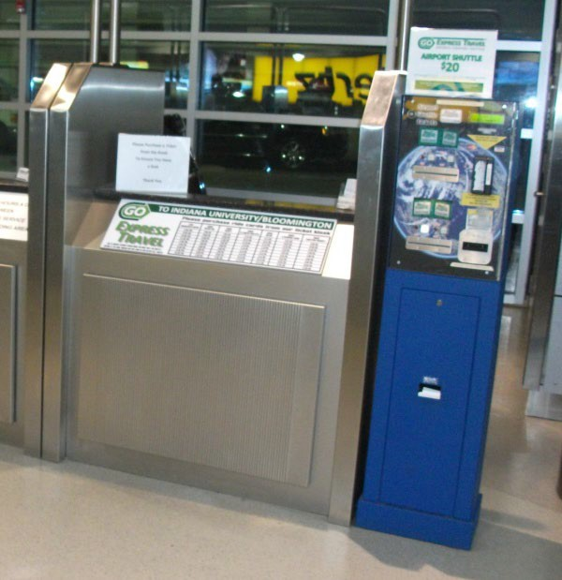
Go Express / Bloomington Shuttle
www.bloomingtonshuttle.com
Telephone: 1-812-332-6004 (or 1-800-589-6004 toll free within US)

Leaves the airport every hour between 6:40am and 10:40pm. (Service begins at 5:40am Thursday, Friday, Sunday and Monday.) The shuttle stops at a few Bloomington hotels and on campus at the Indiana Memorial Union.

Tickets are non-refundable. The cost is $27 one way as on May 2021. The kiosks accept cash or major credit cards. A machine is located inside at each pick-up location.

-The shuttle drivers DO NOT sell tickets and cannot accept cash for transportation. You must buy a ticket through the website or at a kiosk.

Tickets can be purchased online or at the kiosk in the airport Ground Transportation Center. Passengers who make reservations for a specific shuttle time are seated first. Passengers who buy a ride voucher without reserving a specific time are not guaranteed a seat on a given shuttle.

Carte Blanche/Classic Touch Limousine Service
www.classictouchlimo.com
Telephone: 1-812-339-7269 (or 1-800-319-0082 toll free within US)

Reservations are required. Classic Touch is more expensive (approximately $85-$160), but offers 24 hour service and will take you to any address in Bloomington. Use the direct phone located on their kiosk in Ground Transportation Center to notify them of your arrival.

Expect other passengers to share the limo. Departure can be delayed up to 40 minutes if the driver needs to wait for passengers from flights arriving later than yours.

Returning to the airport: Pick up times can change as the limo schedule adjusts for the flight times of shared riders. Call to confirm pick up time within 24 hours of pick up.

Bloomington Transportation
Taxi: Red Tire Taxi Reservation, 1-812-250-8887 or 1-812-269-2690
Safe Ride Taxi 1-812-332-8556
E 2 Taxi 1-812-961-8294

Lyft: Download the app to a smartphone, https://www.lyft.com/cities/bloomington-in
Uber: Download the app to a smartphone, www.uber.com/sign-up

Bloomington Transit (bus service) - $1.00 (as of May 2021) Drivers cannot give change. www.bloomingtontransit.com

IU Campus Bus Service – Free. https://iubus.indiana.edu

